RS 422 to Heraeus Vötsch HT/S 7057 connection

USB-COM422-PLUS1
USB-COM422-PLUS1 Datasheet

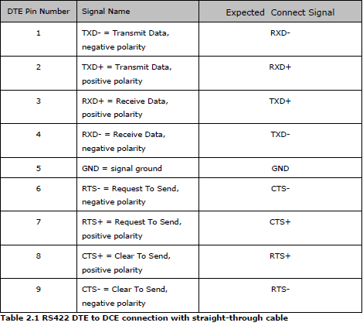

HT/S 7057
Operating Instructions VC 4020 – VC 4057 – VC 7020 – VC 7057 with CTC control

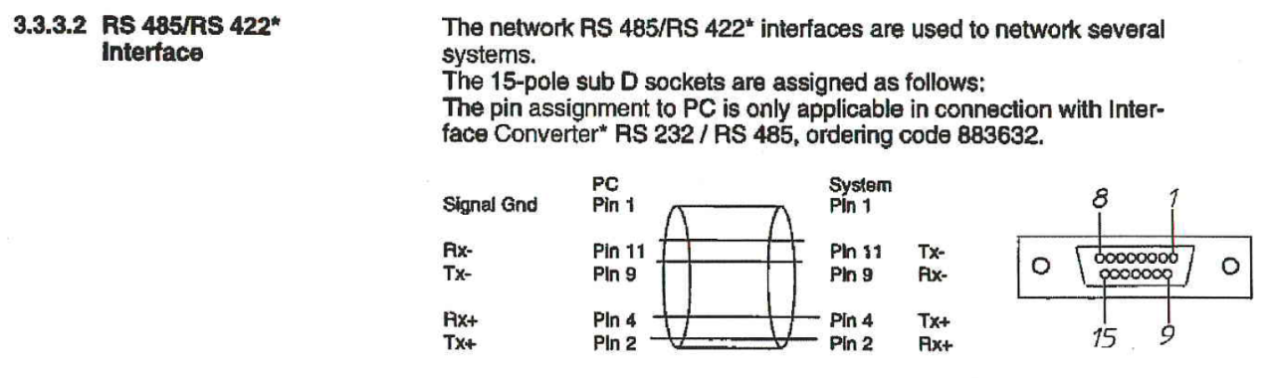

Cable
USB-COM422-PLUS1  9-pole sub D |  | HT/S 7057  15-pole sub D |  | Wire
Signal name | Pin | Signal name | Pin | Wire
Tx- | 1 | Rx- | 9 | Black
Tx+ | 2 | Rx+ | 2 | Brown
Rx+ | 3 | Tx+ | 4 | Orange
Rx- | 4 | Tx- | 11 | Red
GND | 5 | GND | 1 | Yellow

